Airbnb Data Exploration and Analysis
Doug Nolan
Bellevue University
DSC 530: Data Exploration and Analysis
Matthew Metzger
May 29, 2026

Do Airbnb Reviews and Listing Features Help Predict Price?
The purpose of this project is to analyze Airbnb listings and identify the factors that influence pricing, booking availability, and customer reviews. By conducting exploratory data analysis, statistical testing, regression modeling, classification, and clustering, the project aimed to uncover patterns that can help hosts optimize listings and help customers better understand the Airbnb market.
The raw dataset contained 79 columns, including text descriptions, review scores, availability metrics, location details, and host information. Price, among many other variables, was stored as a string and required cleaning. After handling missing values and converting data types, I had a robust data set for modeling. Price was the target variable of the analysis. There were several review-based metrics like, review scores rating, number of reviews, and reviews per month. There were also property-based metrics like accommodates, bedrooms, room type, and availability 365. Initial analysis revealed that reviews alone have limited direct correlation to price. Meaning, highly rated listings do not command premium prices, rather other factors are the influence.
I explored the distribution of the review scores rating. Immediately I saw a very right heavy bar graph and box plot. The mean and median scores were above 4.8, which is insane. My initial thought of the user left reviews being able to dictate price is now feeling less than great. Next, I looked at the distribution of price. Price per night is what the variable is. My data cleaning consisted of removing the top 2% of data. This meant I capped prices at $1,400 per night and less. Next, I checked out the count of listings by room type. Most listings are entire homes or apartments, with a handful being private rooms only.
Moving onto the bivariate analysis. I created three visuals in this section. The first was a scatterplot of review scores against price. The second was a box plot of review scores with each room type having their own plot. Lastly, and most useful I created two correlation matrices. The first was with all the original data, and the second was with the cleansed data. I did the entire analysis without removing the top 2% of price outliers and found nothing was useful. I had to circle back and redo a good chunk again but instead using the cleansed data. This yielded better and more intuitive results. I would expect the price of a listing to be influenced by the number of guests it accommodates and the number of bedrooms it has.
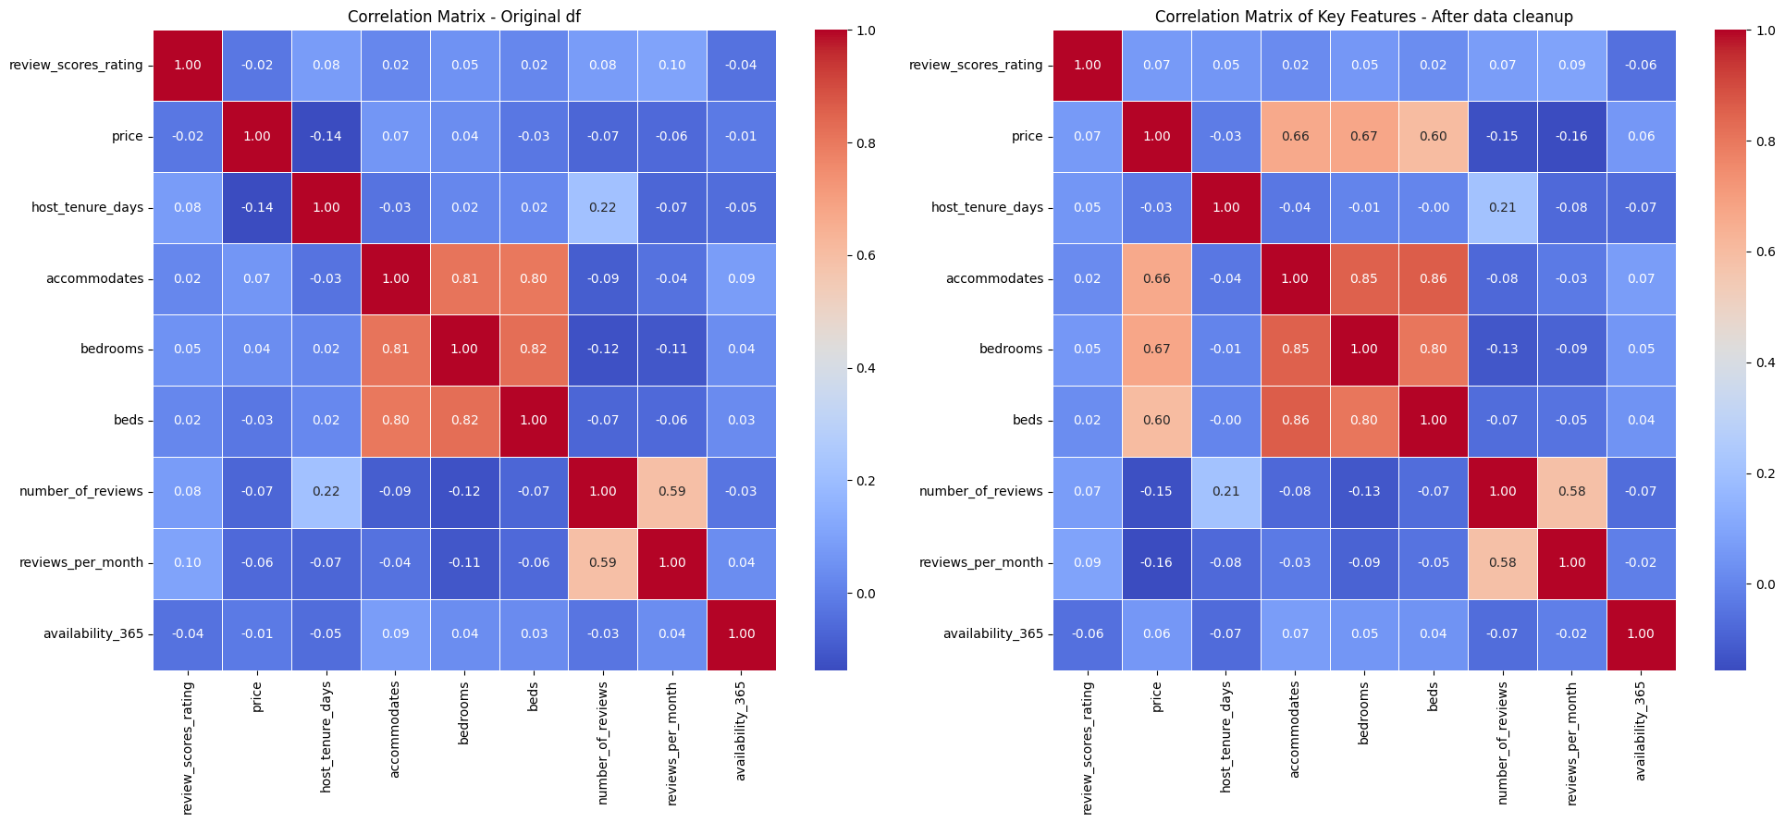
For my hypothesis testing I looked at the variable, host is superhost. Null Hypothesis: There is no significant difference in Airbnb prices between superhosts and non-superhosts. Alternative Hypothesis: There is a significant difference in Airbnb prices between superhosts and non-superhosts. An Airbnb superhost is defined as someone who delivers outstanding hospitality, earning a special badge on their profile and listings to help guests identify them as reliable and top-rated. To start I filled any missing values for the column as false and then I converted the values to Boolean. After conducting a two-t test I got a negative T statistic and a large and insignificant P value. T Statistic ~ -0.57, P value ~0.57. I failed to reject the null hypothesis.
The regression analysis yielded an R-squared value of 0.527 and RMSE of $139. The features included: Accommodates, bedrooms, review scores rating, and availability 365. I also ran a classification analysis with the focus on seeing if I can correctly identify if a listing is instantly bookable. The weighted averages for the report are as follows: precision 0.60, recall 0.63, and f1-score 0.58. The precision is slightly above just guessing all one variable. The model successfully identifies 63% of the actual instant bookable listings. Overall, the results are fun, but not necessarily accurate or usable.
K-Means clustering identified three distinct market segments. Cluster 0 are premium priced and highly available listings. Cluster 1 was high demand and budget listing. This leaves Cluster 2 and mid-range and limited available listings. My initial thought is that pricing a listing too high will get you lumped into Cluster 0. It may be aspirational to make the most amount of money on your listing with a premium price, but if that listing goes unrented for a long time you would’ve been better to get less margin and more bookings.
I trained two models to test predictive modeling. Using the features of: accommodates, bedrooms, review scores rating, availability 365. Random Forest outperformed Gradient Boosting. Below you can see full details of the models’ performances and comparison to linear regression. It makes sense that the number of bedrooms is the strongest driver of price. In addition to the bedrooms, accommodates is another strong positive influence on price. The more guests a listing can host the higher the price will be.
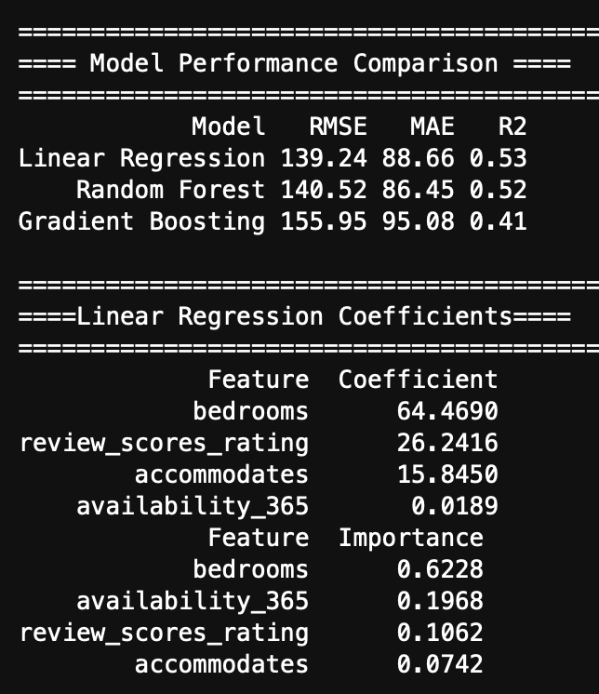
The analysis tells a clear story. Price in San Diego’s Airbnb market is primarily driven by tangible property attributes (bedrooms, accommodates) and operational availability, with guest reviews acting as a valuable but secondary enhancer. Reviews do help predict the price, particularly when combined with other signals, but they are not the dominant factor. I think the limited distribution of the reviews was the limiting factor for effectiveness. All the reviews being within a few tenths of points of each other made it a less than useful feature. Maybe if the review scoring was on a 0-100 scale and there was more differentiation in the scores it would be a useful metric in this analysis. If I were a host and was listing my property in San Diego, I would price units based on how many guests it accommodates and how many bedrooms it has. I would not force myself to have the listing available all year round, since those listings didn’t necessarily drive higher prices. I would focus more on getting a 5 star rating from a guest than being available on every day of the year, quality over quantity.

